Student Learning & AI Usage Impact Analysis

- Project Overview
This project analyzes the progress in students learning by AI usage. The dataset includes details of 50000 distinct students from different domains. The goal is to establish a relationship between AI usage and different factors such as post-semester CGPA, retention score, etc.

- Dataset Summary
The dataset is imported from Kaggle.
- Rows: 50000
- Columns: 16
- Key features:
-Student Demographics (Student ID , Major Category , Year of Study)
-Academic Performance (Pre-Semester CGPA , Post-Semester CGPA , Skill Retention Score)
-AI Usage & Learning Behavior (Weekly Gen AI Hours, Primary AI Use Case , Number of AI Tools Used , Paid Subscription , Prompt Engineering Skill)
-Student Well-Being (Anxiety Level , Burnout Risk , Perceived AI Dependency)

- Exploratory Data Analysis using Python
Began with data preparation and cleaning in Python.
- Data Loading: Imported the dataset using pandas.
- Initial Exploration: Used ai.info() to check structure and ai.describe() for summary statistics.
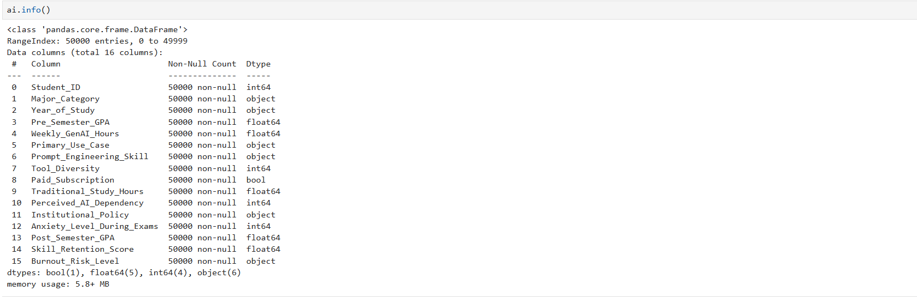
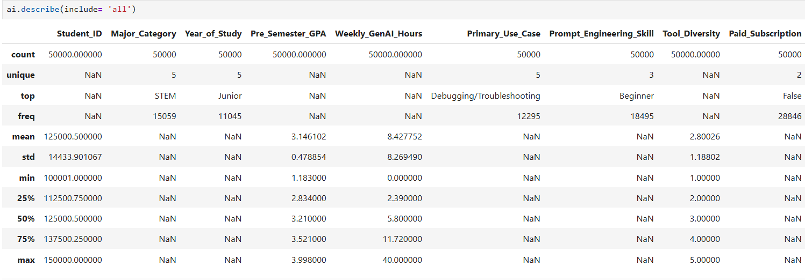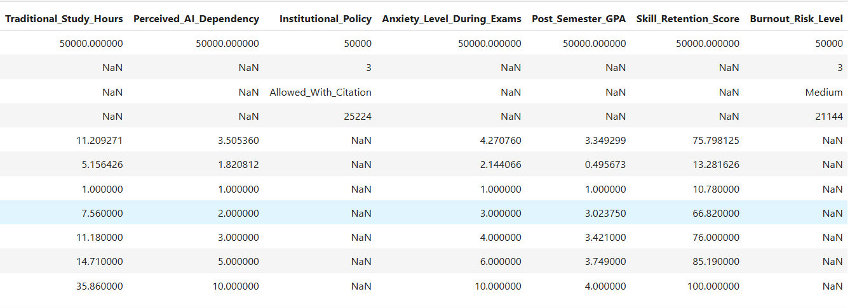
- Missing Data: Checked for missing data by using ai.isnull().sum(). There were no missing values.
- Column Standardization: Renamed columns into lowercase for better documentation.
- Feature Engineering:
- Created performance_status column by using post and pre semester cgpa.
- Created anxiety_level column by categorizing the score into low , medium and high.
- Database Integration : Connected Python script to PostgreSQL and loaded the cleaned Dataframe into the database for SQL analysis.

- Data Analysis using SQL
Performed structured analysis in PostgreSQL to answer key questions.
- Number of Students by Major Category – Found number of students in particular major category.
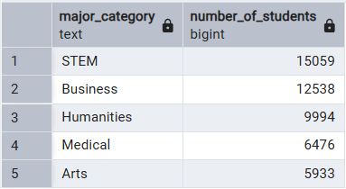

- Average Pre and Post Semester Cgpa By Major Category – Figured out average of pre and post semester cgpa for different categories.
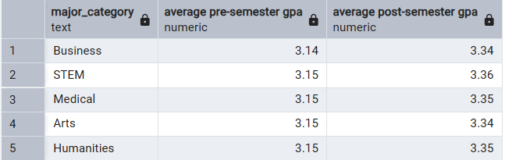

- Impact of AI usage – Identified number of students who improved their performance.
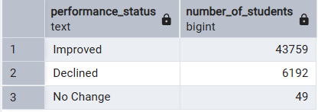

- Average Weekly Hours spend by each category on GenAI –
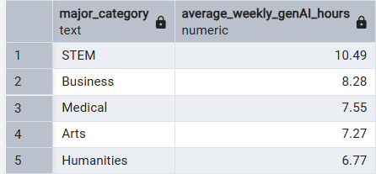

- Average Time Spent by Paid and Non-Paid Users- Identified the number of students who spend more average time on GenAI from the group(paid & non-paid users).
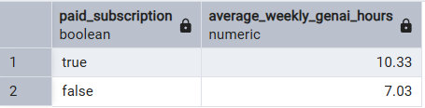

- Students facing High Anxiety Level by Major Category- Identified total number of students from each major category who are facing high anxiety level.
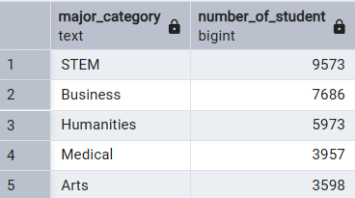

- Major category contributing the highest number of students to the overall top 20 students
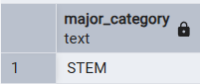

- Dashboard in Power BI
Built an interactive dashboard in Power BI to present insights visually.
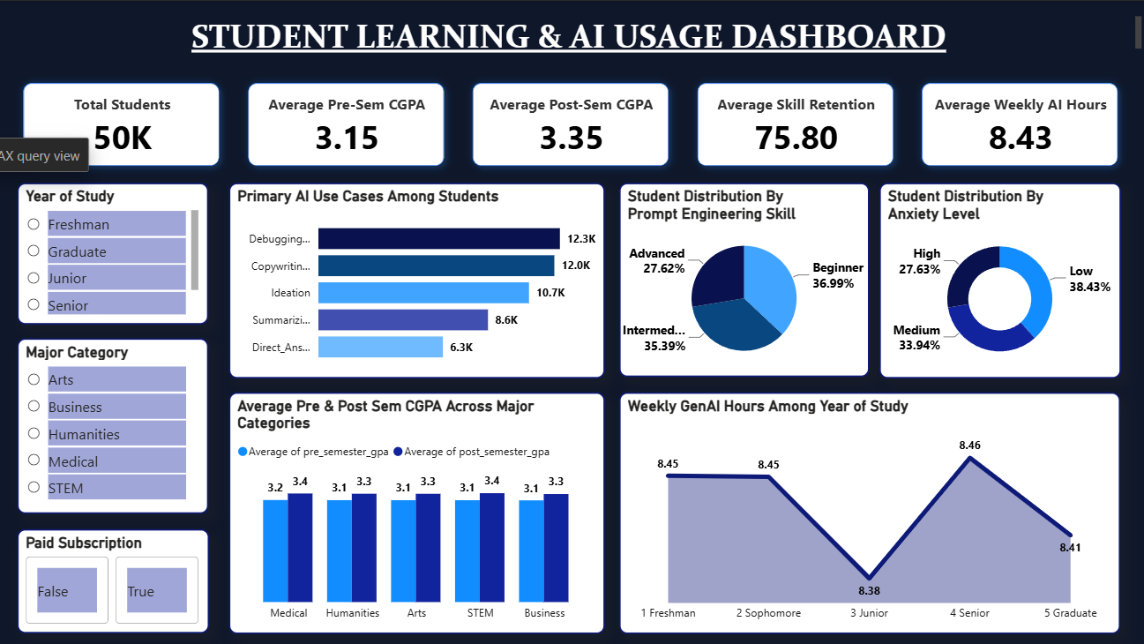

- Insights
- The average post semester CGPA was higher than the pre semester CGPA, indicates an overall improvement in academic performance.
- Arts and Humanities students primarily used GenAI for copywriting whereas Business and Medical students used it for summarizing/ reading.
- Students with paid AI subscriptions spend more time using AI compared to non-paid users.
- AI usage patterns differed across years of study , with Senior students spending the most average hours using GenAI.
- All major categories except STEM consist major portion of students who are beginner in prompt engineering.
- STEM Sophomore are facing high anxiety level.

